**Artificial night at light differentially affects birds in isolation or social conditions**

Cassandra K. Hui1*, Yong Zhang2, Jenny Q. Ouyang1

1 Department of Biology, University of Nevada, Reno

1664 N Virginia St, Reno, NV 89557

2 Department …

*Corresponding author: chui@nevada.unr.edu

**Abstract**

**Introduction**

Across taxa, the circadian rhythm oscillates activation and repression through core clock genes. Organisms sync their internal 24-hour rhythms using external cues, called zeitgebers, such as light and temperature. In the absence of these cues, a negative transcriptional feedback loop involving core proteins sustains these rhythms (*1*). Two transcriptional activators, CLOCK and BMAL, promote gene transcription, including two repressors, Period (Per) and Cryptochrome (Cry), generating a feedback loop. Light-induced degradation of the PER/CRY complex aids in adaption to environment changes (*1*).

Rapid global urbanization has increased artificial light at night (ALAN), with light pollution now acknowledged as a disruptive environmental pollutant (*2*). ALAN disrupts core physiological and behavioral processes such as hormone secretion, activity levels, and circadian gene expression, even at dim levels (*3, 4*). However, much of this research has used isolated animals.

Social interactions strongly effect physiology, including circadian regulation (*5*). Previous research has demonstrated that social interactions can restore arrhythmic behavior in birds (*6*), and increase circadian gene expression in insects (*7*). Therefore, we explored whether social interactions could mitigate ALAN's negative effects.

We analyzed activity levels, melatonin, and circadian gene expression in zebra finches (*Taeniopygia guttata*) exposed to ALAN isolated or social (grouped) compared to birds in control dark nights in isolation or social conditions. We predicted that socially interacting birds under ALAN would exhibit fewer negative effects compared to their isolated counterparts. And those social birds, weather exposed to ALAN or not, would have similar circadian gene expression and melatonin levels, whereas in isolation, ALAN would disrupt both.

**Methods**

*Experimental Design*

Zebra finches were caged indoors individually (47 x 31 x 36cm cages) or grouped (47 x 93 x 36 cm cages) and entrained to 12 hours light and 12 hours dark (12L:12D) for three weeks. Grouped (social) cages held 3 males and 3 females. For daylight, we used 1.4-Watt 5000 K light emitting diode (LED) rated at 95 Lumens lights at 9:00 (zeitgeber time (ZT) 0) and lights off at 21:00 (ZT 12). Birds were given food and water *ad libitum*. Each cage contained a mechanized perch that relayed hop activity to MATLAB every minute. Cages had individual light-occlusion shades and constant white noise in the background to limit visual and acoustic cues across cages. We also video recorded cages containing groups of birds every half hour for two minutes (6).

Birds were randomly assigned to one of four conditions: social ALAN (12L:12L dim), isolated ALAN (12L:12L dim), social control (12L:12D), and isolated control (12L:12D). As determined by One-Way ANOVA, groups did not differ in initial mass (p= 0.247). After the 3-week entertainment period, we sacrificed the birds at four-time points: ZT 1, ZT 7, ZT 13, and ZT19. ALAN was standardized to around 5 lux ± 0.01 from a 20 x 1.5 cm 5000 K broad spectrum LED strip. This was done with an Extech Easyview Digital Light Meter (model EA13) and lux was calculated using a mean measurement at perch height and two opposing base corners. For a full-spectrum description of the lights, please see (*8*).

*Real-Time qPCR*

Real-time PCR quantification was based on SYBR-Green. Circadian gene expression in the hypothalamus was detected by dissection of the hypothalamus, homogenized, and analyzed in triplicate for technical repeats. Total RNA was isolated from collected tissues using Trizol (Life Technologies, Carlsbad, California) and quantified using Nanodrop 1000 (Thermo Scientific). Reverse transcription was done from 3 mg of total RNA through Versco cDNA synthesis kit. The primers were designed using Primer 3 based on Zebra Finch Cry1, Bmal1, Per2, and Per3 genes (Table S1). Amplicon abundance was calculated using the 2-∆∆CT method.

*Endocrinology*

Melatonin was measured from plasma using an enzyme-linked immunoassay kit (Aviva Systems Biology OKEH02566) on two 96-well plates according to manufacturer procedures. When available, 25 mL of plasma was diluted and used for each individual run in duplicates, samples with less than 50 mL of plasma were diluted more. The plate was read at 450 nm using a standard microplate reader (BioTek Synergy HTX multi-mode reader) and BioteGen5 data analysis software (BioTek Instruments, Inc, Winooski, Vermont). Optical density absorbance (OD) was contrasted from mean blank OD to obtain relative sample OD and then regressed against a standard curve to calculate final melatonin concentrations.

*Statistical Analyses*

Data and graphs were analyzed using R version 4.1.2 (R Development Core Team, 2019) and models were built to test for the effect of ALAN on activity, melatonin, and circadian gene rhythmicity. A Welch two-sample t-test was used to test for differences in nocturnal activity between control and ALAN for individually caged and social birds. Cosinor (version 1.2.3 (Barnett and Dobson, 2010)) was used for rhythmic analysis of melatonin to test for treatment effects on amplitude (i.e. the difference between peak and the mean value of wave) and phase (i.e. time of peak expression in wave). A Student’s t-test with Welch’s corrections was used to test for the effects of ALAN on cardiac gene expression at each timepoint. CircaCompare (version 0.1.1) was used for rhythmic analysis of gene expression.

*Ethics Statement*

All procedures were conducted in accordance with the National Institute of Health Ethical Use of Animals and approved by the University of Nevada, Reno Institutional Animal Care, and Use Committee.

**Results**

*Activity*

Birds exposed to ALAN were more active at night regardless of social condition (Figure 1). Hop activity measured via perch recordings showed that birds had significantly higher total nocturnal activity under ALAN regardless of social condition (Isolated: t = 7.18, p < 0.01, social: t = 6.84, p < 0.01). However, nocturnal activity decreased over the experimental days (Figure 1A).

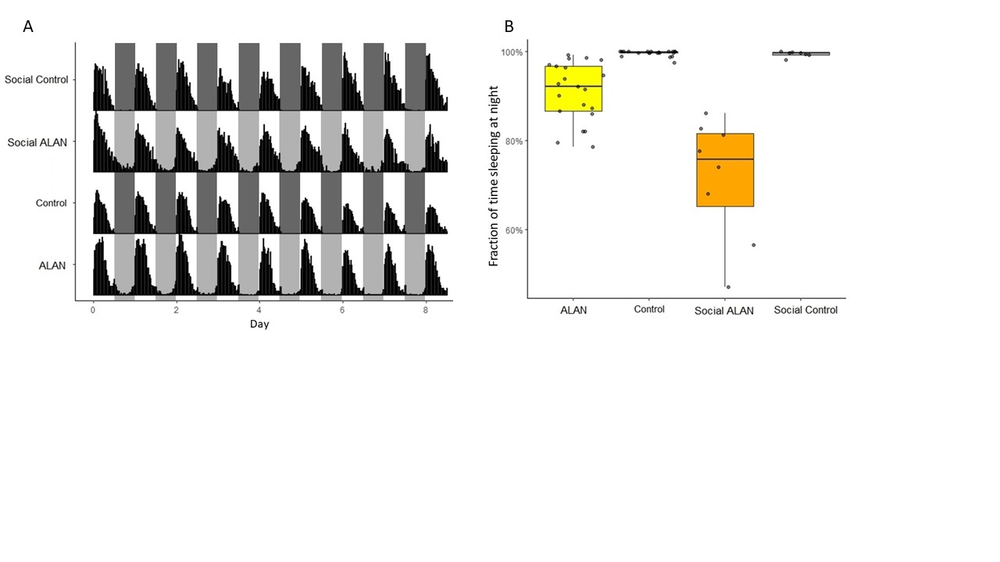

**Figure 1. Activity and sleep for birds exposed to dim ALAN either in isolation or social conditions.** Nocturnal activity was calculated over 9 days of experimental treatment with birds either exposed to ALAN or control birds in dark nights. (A) An actogram of the average activity for each treatment group over each day. (B) The fraction of time spent sleeping at night over the experimental period averaged by treatment group.

*Melatonin*

Melatonin concentrations oscillated throughout the day for all groups, with a peak at night for isolated control birds and social birds, but a peak during the day for isolated birds exposed to ALAN (Figure 2). The amplitude (Isolated: z = 0.12, p = 0.73; Social: z = 0.04, p = 0.84) and phase (Isolated: z = 0.06, p = 0.81; Social: z = 0.16, p = 0.69) of melatonin also did not differ between birds exposed to ALAN in either isolation or social conditions.

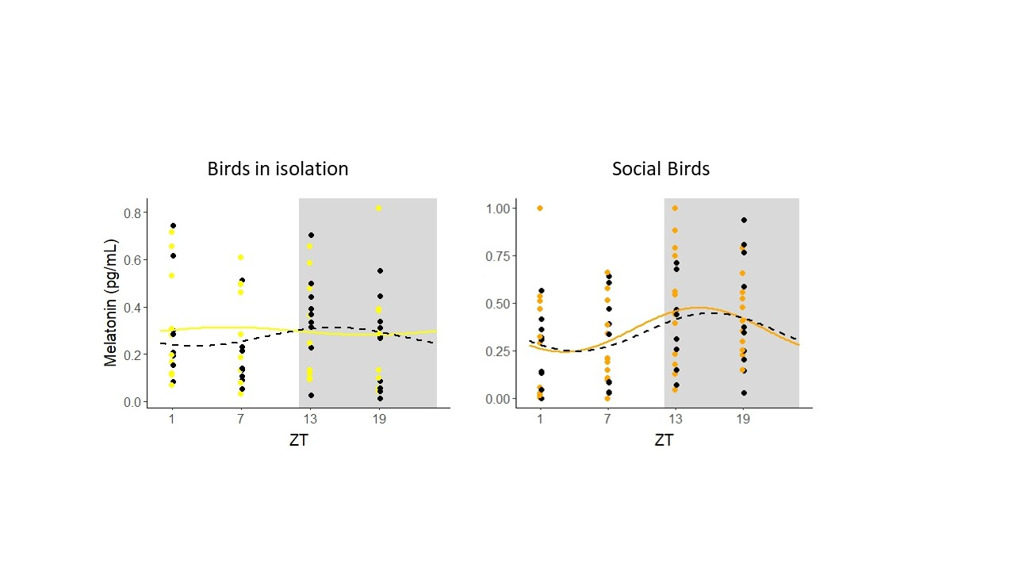

**Figure 2. Levels of melatonin throughout the day for birds exposed to ALAN either in isolation or social conditions.** Circadian rhythm of melatonin with fitted cosine curve overlaid. Shaded portions represent nighttime (ZT 12-ZT 24). The left panel shows birds in isolation and the right panel shows birds in social conditions, black is isolated and social control, yellow is ALAN, and orange is social ALAN. Samples were collected after 10 days of ALAN exposure at ZT 1, ZT 7, ZT 13, and ZT 19. Significant differences were not detected between birds exposed to ALAN and control birds in either isolation or social groups.

*Gene Expression*

There were strong daily rhythms in circadian genes *Cry1, Per2,* and *Per3* expression in the brains regardless of treatment (all p-values < 0.01: Figure 4). Expression of *Bmal1* showed weaker rhythmicity (Isolated control: p = 0.08, Isolated ALAN: p = 0.01, Social control: p = 0.03, Social ALAN: p < 0.01). The phase and amplitude did not significantly differ between controls and ALAN exposed birds in expression of *Cry1, Per2,* and *Per3* (Table 1). There was a significant difference in phase of *Bmal1* expression between social control and social ALAN birds (p < 0.01) that wasn’t seen in isolated birds (p = 0.77). Expression of *Bmal1* was significantly decreased in birds exposed to ALAN under social conditions at ZT 13 (t = -3.30, p = 0.01; Figure 4), that was not seen in isolated birds (t = 0.22, p = 0.83). Both groups exposed to ALAN, in isolation or social conditions, significantly decreased expression of *Per3* from their respective controls at ZT 1 (Isolated: t = -2.48, p = 0.03, Social: t = -2.42, p = 0.04).

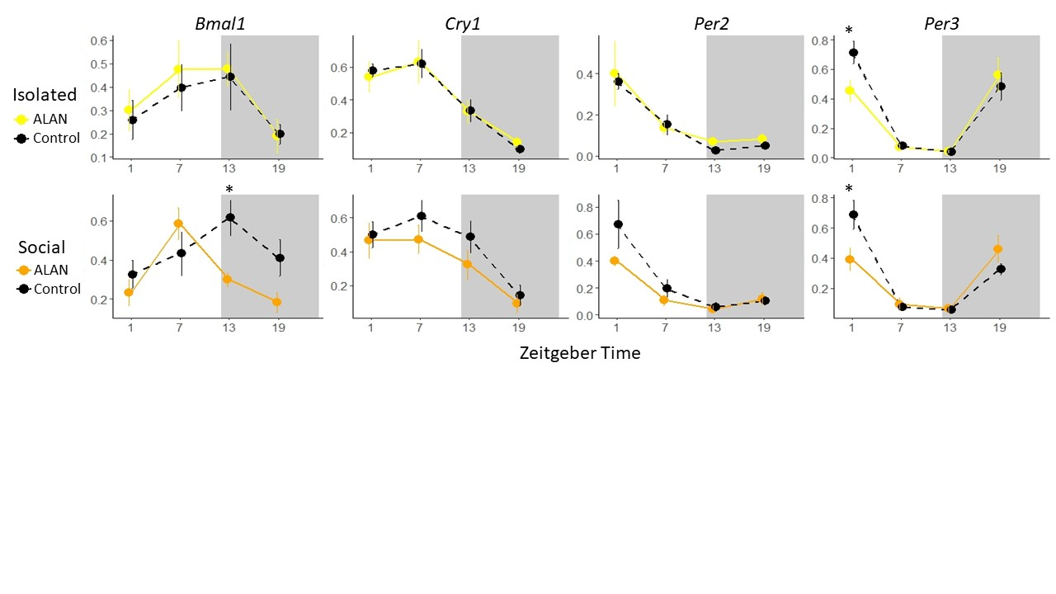

**Figure 4. Expression of four circadian genes in the brain throughout the day of birds exposed to ALAN either is isolation or social conditions.** The top panels show isolated birds and the bottom panels show birds in social conditions. Values are reported as mean ± 1 SE of normalized expression collected at four timepoints throughout the day. Shaded portions represent nighttime (ZT 12-ZT 24). Birds exposed to ALAN were significantly different from controls in *Per3* expression at ZT 1 (Isolated: p = 0.03, Social: p = 0.04) and only social ALAN birds were significantly different from social controls in *Bmal1* expression at ZT 13 (p = 0.01). Significance stars: ‘*’ p < 0.05, ‘**’ p < 0.01, ‘***’ p < 0.001.

**Table 1.** Rhythmic analysis comparing difference in phase of expression of four circadian genes between birds exposed to ALAN and controls either in isolation or social conditions. Four timepoints were collected throughout the day at ZT 1, 7, 13, and 19.

|  |  |  |  |
| --- | --- | --- | --- |
| **Condition** | **Gene** | **Difference** | **p-value** |
|  | *Bmal1* | 0.70 | 0.77 |
| Isolated | *Cry1* | -0.14 | 0.89 |
|  | *Per2* | 0.61 | 0.63 |
|  | *Per3* | 1.20 | 0.08 |
|  | *Bmal1* | 5.00 | **0.01** |
| Social | *Cry1* | 1.44 | 0.36 |
|  | *Per2* | 0.96 | 0.55 |
|  | *Per3* | 1.70 | 0.05 |

There were also strong daily rhythms in circadian genes *Bmal1, Cry1, Per2,* and *Per3* expression in the livers regardless of treatment (all p-values < 0.01: Figure 5). The phase and amplitude of the rhythms did not significantly differ between controls and ALAN exposed birds in expression of *Bmal1, Cry1,* and *Per2*. There was a significant increase in amplitude of *Per3* for birds exposed to ALAN in social conditions (p = 0.05) that wasn’t seen in isolated birds (p = 0.26). At individual timepoints there were no significant differences between controls and birds exposed to ALAN in isolation. However, birds exposed to ALAN in social conditions significantly decreased *Bmal1* expression at ZT 13 (t = -2.60, p = 0.03) and *Per3* expression at ZT 7 (t = -2.68, p = 0.05).

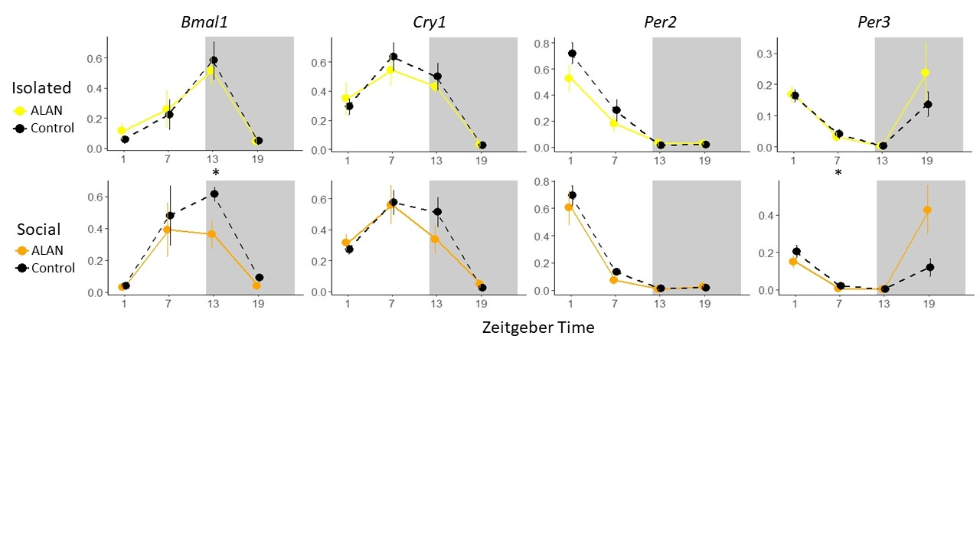

**Figure 5. Expression of four circadian genes in the liver throughout the day of birds exposed to ALAN either is isolation or social conditions.** The top panels show isolated birds and the bottom panels show birds in social conditions. Values are reported as mean ± 1 SE of normalized expression collected at four timepoints throughout the day. Shaded portions represent nighttime (ZT 12-ZT 24). Birds exposed to ALAN in social conditions were significantly different from social controls in *Bmal1* expression at ZT 13 (p = 0.03) and *Per3* expression at ZT 7 (p = 0.05). Significance stars: ‘*’ p < 0.05, ‘**’ p < 0.01, ‘***’ p < 0.001.

**Discussion**

“Synaptic strength and function in wake and sleep are coupled to distinct genetic signatures. In rodents, several microarray experiments indicate that wakefulness is associated to the expression of activity-regulated genes which control experience dependent plasticity. The expression of these genes (such as *Arc*, *Bdnf*, *Homer1a*) was found to be modulated by ERK. In rodents, ERK phosphorylation in cortical neurons increases or decreases with wake and sleep. Indeed, deletion or inhibition of ERK phosphorylation were shown to modulate wake and sleep duration ([Mikhail et al., 2017](https://www.frontiersin.org/articles/10.3389/fncir.2023.1099598/full#B71)). Therefore, the circadian regulation of ERK signaling pathway correlates the waking experience with synaptic plasticity, while sleep renormalizes synaptic strength, in line with the hypothesis that *“sleep is the price for synaptic plasticity”* ([Tononi and Cirelli, 2014](https://www.frontiersin.org/articles/10.3389/fncir.2023.1099598/full" \l "B111)). The cyclic activation of mTOR, that was shown to contribute to memory consolidation in hippocampus ([Saraf et al., 2014](https://www.frontiersin.org/articles/10.3389/fncir.2023.1099598/full#B93); [Snider et al., 2018](https://www.frontiersin.org/articles/10.3389/fncir.2023.1099598/full#B104)) is likely to contribute to this more general process of synaptic homeostasis, although direct evidence is still missing. Circadian oscillations of the ERK signaling pathway were reported to regulate complex functions such as sleep and learning and memory also in invertebrate, highlighting the robustness of such circadian intracellular signaling cascade in regulating synaptic homeostasis from fly to mammals. Sleep deprivation and social enrichment was found to increase ERK phosphorylation, while disruption of ERK signaling pathway reduced sleep duration and prevented neuronal plasticity triggered by social environmental enrichment. Using a CRE luciferase reporter in flies, ERK phosphorylation was shown to be coupled to CREB activation since CRE-luciferase activity increased with ERK phosphorylation and was reduced by ERK disruption ([Vanderheyden et al., 2013](https://www.frontiersin.org/articles/10.3389/fncir.2023.1099598/full#B114)). These data again indicate that the diurnal regulation of ERK signaling translates neuronal activity in synaptic plasticity and controls sleep and wake duration. This regulation is biunivocal, as disrupting sleep/wakefulness duration alters ERK signaling and neuronal plasticity.” (*9*)

Could be that the birds in isolation are already stressed but the birds in social conditions are more susceptible to exterior stressors like ALAN.

**Acknowledgments**

**Supplemental**

**Supplementary Table 1:** Primers sequences designed based on Zebra Finch *Cry1*, *Bmal, Per2*, *Per3,* and 18S genes for qPCR.

|  |  |  |
| --- | --- | --- |
| **Primer** | | **Sequence (5’- 3’)** |
| *Cry1* | forward | GGTCTTCTTGCAACTGTGCC |
| reverse | AGCTGAGCTCCTCCTGTACT |
| *Bmal1* | forward | ATGGCTGTCCAGCACATGAA |
| reverse | CACAGCCCACAACGAAAAGG |
| *Per2* | forward | AGCAAGACCTGATGCCTGTC |
| reverse | ACATCGGACGTGAACAA AA |
| *Per3* | forward | TTGTGGCCAAGGTGATTCCC |
| reverse | TGTCTCTGAGGTTTCTGGCG |
| *18S* | forward | GCCGCTAGAGGTGAAATTCTTA |
| reverse | CTTTCGCTCTGGTCCGTCTT |

**References**

1. A. Patke, M. W. Young, S. Axelrod, Molecular mechanisms and physiological importance of circadian rhythms. *Nature Reviews Molecular Cell Biology* **21**, 67-84 (2020).

2. D. M. Dominoni, R. J. Nelson, Artificial light at night as an environmental pollutant: An integrative approach across taxa, biological functions, and scientific disciplines. *Journal of Experimental Zoology Part a-Ecological and Integrative Physiology* **329**, 387-393 (2018).

3. D. M. Dominoni *et al.*, Artificial light at night leads to circadian disruption in a songbird: integrated evidence from behavioural, genomic and metabolomic data. *bioRxiv*, 2020.2012.2018.423473 (2021).

4. S. Moaraf *et al.*, Artificial light at night affects brain plasticity and melatonin in birds. *Neuroscience Letters* **716**, (2020).

5. O. Siehler, S. Wang, G. Bloch, Social synchronization of circadian rhythms with a focus on honeybees. *Philosophical Transactions of the Royal Society B-Biological Sciences* **376**, (2021).

6. N. A. Jha, V. Kumar, Female conspecifics restore rhythmic singing behaviour in arrhythmic male zebra finches. *Journal of Biosciences* **42**, 139-147 (2017).

7. A. Rath, M. Benita, J. Doron, I. Scharf, D. Gottlieb, Social communication activates the circadian gene Tctimeless in Tribolium castaneum. *Scientific Reports* **11**, (2021).

8. V. J. Alaasam *et al.*, Effects of dim artificial light at night on locomotor activity, cardiovascular physiology, and circadian clock genes in a diurnal songbird. *Environmental Pollution* **282**, (2021).

9. C. Lodovichi, G. M. Ratto, Control of circadian rhythm on cortical excitability and synaptic plasticity. *Frontiers in Neural Circuits* **17**, (2023).